---------------------------------------------------------------

Link for GitHub

<https://github.com/pradyumanp/java-fsd>

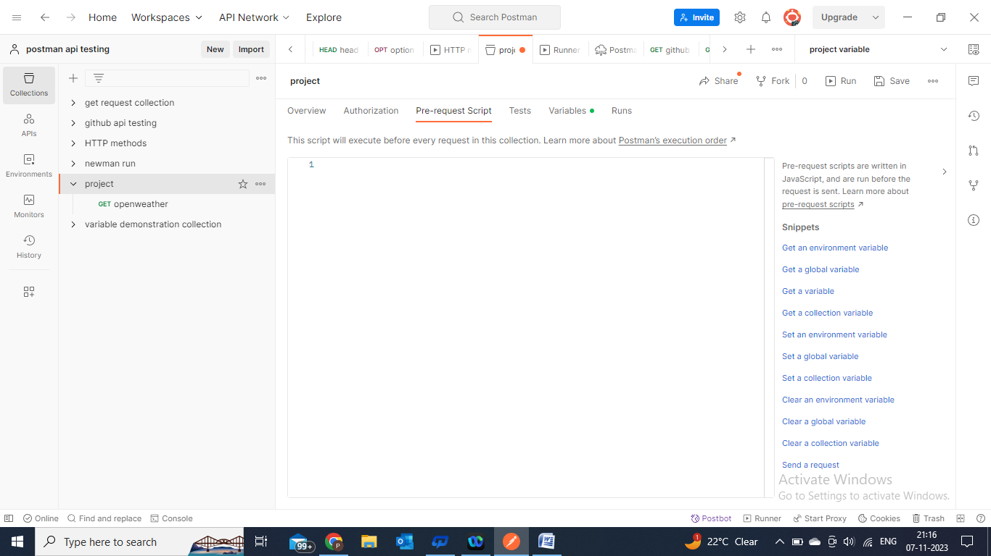

Now we create a collection

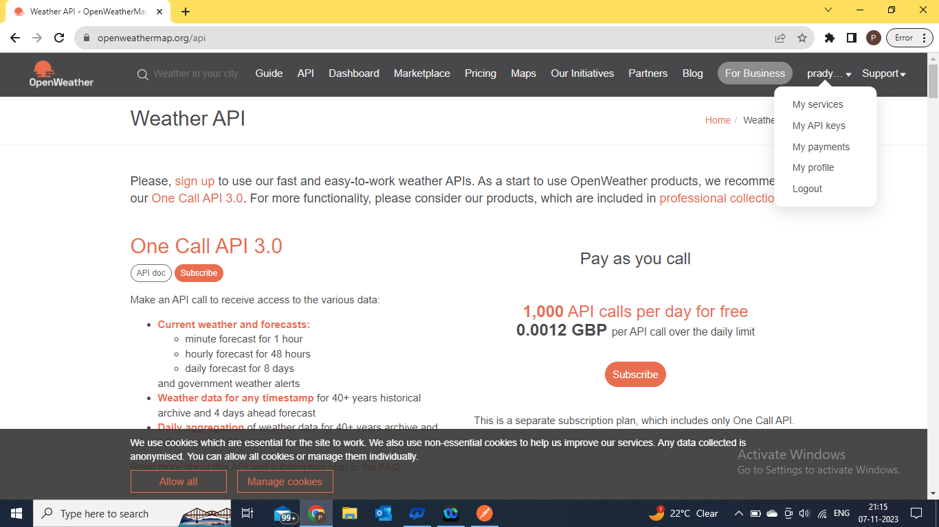

Now add request

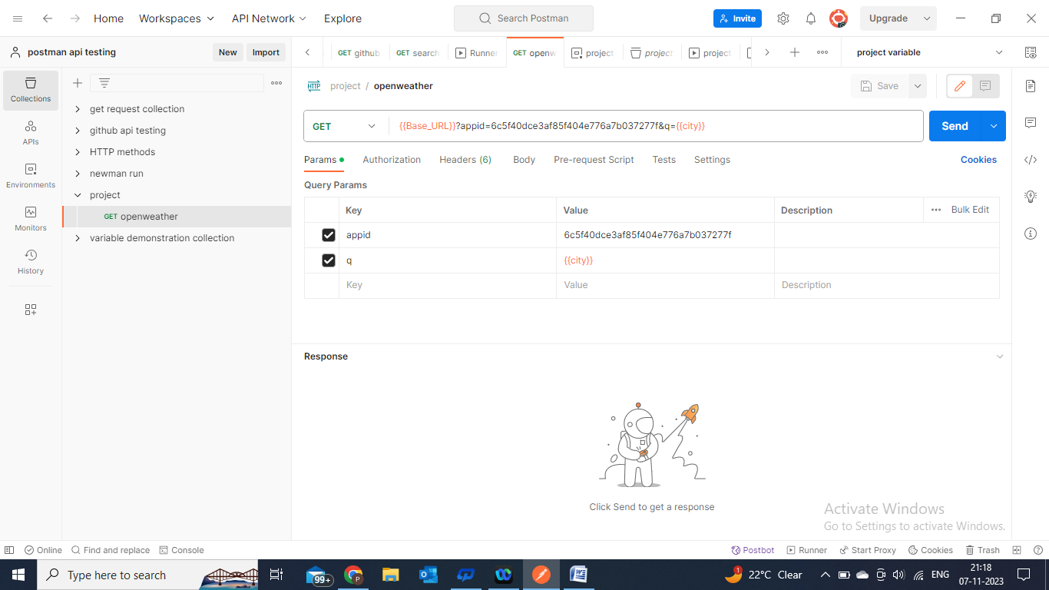

now we took some data from excel sheet

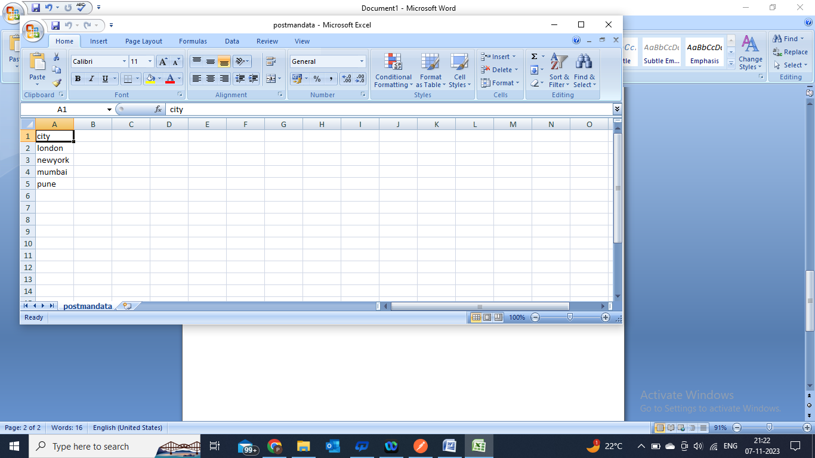

Now we run our collection

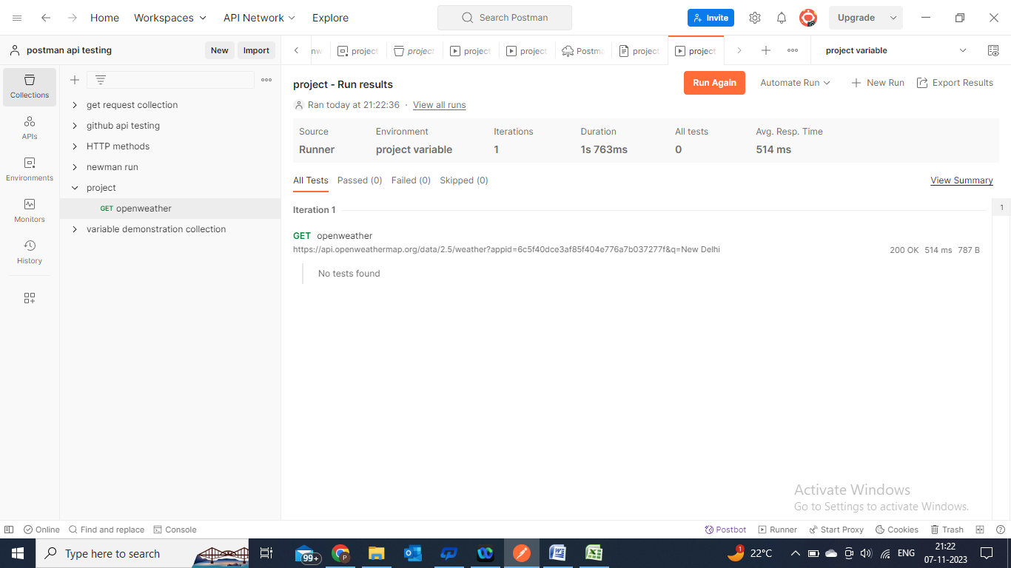

We get desired output.

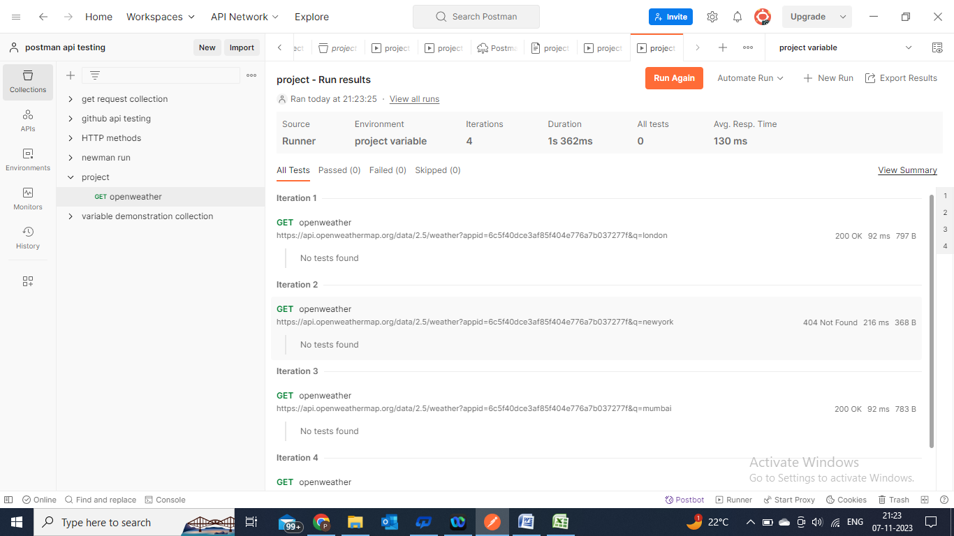

This is our exc el sheet output.